

PRODUCT SPECIFICATIONS
FOR CUSTOMER: ______________________ □ : APPROVAL FOR SPECIFICATION
CUSTOMER MODEL NO. ________________ □ : APPROVAL FOR SAMPLE
Module No.: ZW-T070JWHA-11 Date : 2022-08-23

Table of Contents
No. | Item | Page
1 | Cover Sheet(Table of Contents) | P1
2 | Revision Record | P2
3 | General Specifications | P3
4 | Outline Drawing | P4
5 | Absolute Maximum Ratings | P5
6 | Electrical Specifications | P6-P11
7 | Optical Characteristics | P12-P15
8 | Reliability Test Items and Criteria | P16
9 | Precautions for Use of LCD Modules | P17-P18

For Customer’s Acceptance:
Approved By | Comment

PREPARED | CHECKED | VERIFIED BY QA DEPT | VERIFIED BY R&D DEPT
XZX

2. Revision Record
Date | Rev.No. | Page | Revision Items | Prepared
2022-08-23 | V0 |  | The first release | XZX

3. General Specifications
ZW-T070JWHA-11 is a TFT-LCD module. It is composed of a TFT-LCD panel, driver IC, FPC, a back light unit. The 7.0′′ display area contains 800xRGBx480 pixels and can display up to 16.7M colors. This product accords with RoHS environmental criterion.

Item | Contents | Unit | Note
LCD Type | TFT/ Normally Black | -
Display color | 262K
Viewing Direction | ALL | O’Clock
Operating temperature | -20~+70 | ℃
Storage temperature | -30~+80 | ℃
Module size | 165.00*104.60*5.30 | mm
Active Area(W×H) | 154.40x91.44 | mm
Number of Dots | 800x480 | dots
Controller | HX5281 | -
Power Supply Voltage | 3.3 | V
Backlight | 3S8P-LEDs (white) | pcs
Weight | --- | g
Interface | RGB666 | -

Note 1: Color tune is slightly changed by temperature and driving voltage.
Note 2: Without FPC and Solder.

Outline Drawing

5. Absolute Maximum Ratings(Ta=25℃)

5.1 Electrical Absolute Maximum Ratings.(Vss=0V ,Ta=25℃)
Item | Symbol | Min. | Max. | Unit | Note
Power Supply Voltage | V_{CC} | -0.3 | 4.6 | V | 1，2

Notes:
1. If the module is above these absolute maximum ratings. It may become permanently damaged. Using the module within the following electrical characteristic conditions are also exceeded, the module will malfunction and cause poor reliability.
2. V_{CC}>V_{SS} must be maintained.

5.2 Environmental Absolute Maximum Ratings.

Item | Storage |  | Operating |  | Note
Item | MIN. | MAX. | MIN. | MAX. | Note
Ambient Temperature | -20℃ | 70℃ | -30℃ | 80℃ | 1,2
Humidity | - | - | - | - | 3
1. The response time will become lower when operated at low temperature.
2. Background color changes slightly depending on ambient temperature.
The phenomenon is reversible.
3. Ta<=40℃:85%RH MAX.
Ta>=40℃:Absolute humidity must be lower than the humidity of 85%RH at 40℃.

6. Electrical Specifications

6.1 Electrical characteristics(Vss=0V ,Ta=25℃) LVDS Mode.
Parameter |  | Symbol | Condition | Min | Typ | Max | Unit | Note
Power supply |  | VCC | Ta=25℃ | 2.6 | 3.3 | 3.6 | V
Input voltage | ‘H’ | V_{IH} | VCC=3.3V | 0.7VCC | - | VCC+0.3 | V
Input voltage | ‘L’ | V_{IL} | VCC=3.3V | -0.3 | - | 0.3VCC | V
Current Consumption |  | I_{DD1} | Normal mode | - | - | - | mA | 1
 |  | I_{DD2} | Sleep mode | - | - | - | mA | 1
Clock Frequency |  | fCLK | - | 5.25 | - | 60 | MHz

Note: 1: Tested in 1╳1 chessboard pattern.

6.2 LED backlight specification(VSS=0V ,Ta=25℃)

Item | Symbol | Condition | Min | Typ | Max | Unit | Note
Supply Voltage | VLED | If=160mA | - | 9 |  | V
Uniformity | ΔBp | If=160mA | 75 | - | - | %
Luminance for LCD(w/o TP) | Lv | If=160mA | - | 380 | - | Cd/m2 | 1

Note:
1：The”LED Life time” is defined as the module brightnees decrease to 50% original brightness at T=25℃
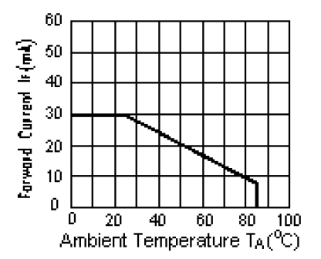

6.3 Interface signals

Pin No. | Symbol | I/O | Function
1~2 | GND | P | Ground.
3 | NC | - | No connection.
4~7 | VCC | P | Power supply.
8 | NC | - | No connection.
9 | DE | I | Data enable signal.
10~12 | GND | P | Ground.
13~15 | B5~B3 | I | Blue data bus.
16 | GND | P | Ground.
17~19 | B2~B0 | I | Blue data bus.
20 | GND | P | Ground.
21~23 | G5~G3 | I | Green data bus.
24 | GND | P | Ground.
25~27 | G2~G0 | I | Green data bus.
28 | GND | P | Ground.
29~31 | R5~R3 | I | Red data bus.
32 | GND | P | Ground.
33~35 | R2~R0 | I | Red data bus.
36~37 | GND | P | Ground.
38 | DCLK | I | Dot clock signal.
39~40 | GND | P | Ground.

6.4 Input signal timing
6.4.1 RGB interface

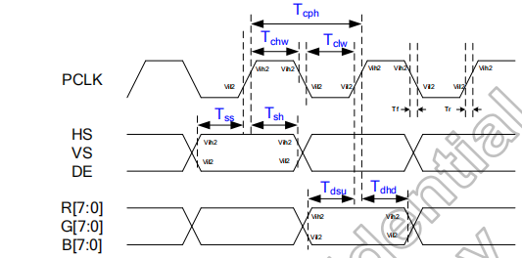
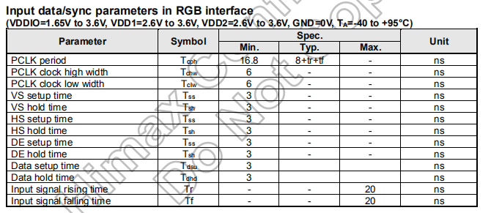
6.4.1 Reset timing
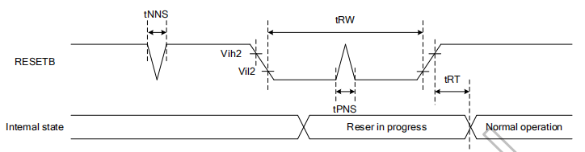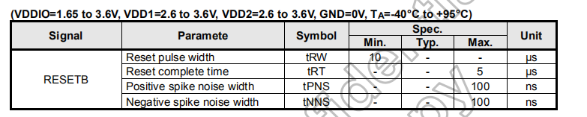

6.5 Electrical Characteristics
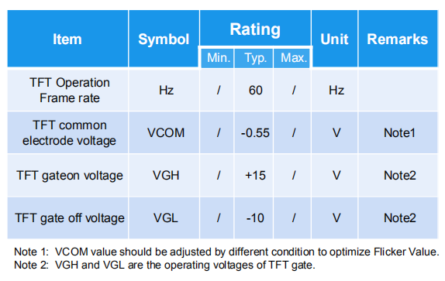

6.5.1 For the digital circuit
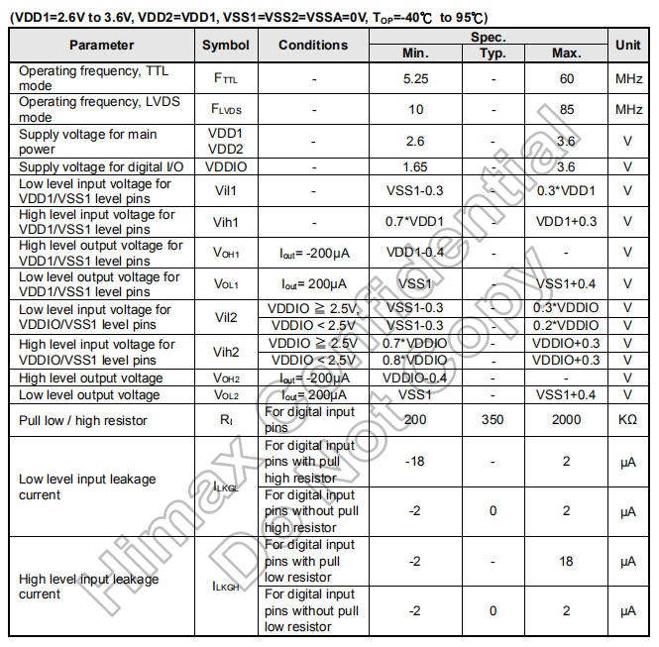

6.5.2 For the analog circuit
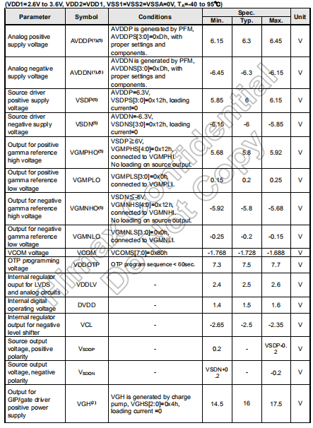

7. Optical Characteristics
Item | Symbol |  | Condition | Min. |  | Typ. | Max. | Unit | Note
Brightness | Bp |  | θ=0°  Φ=0° | - |  | 380 | - | Cd/m² | 1
Uniformity | ⊿Bp |  | θ=0°  Φ=0° | 75 |  | - | - | % | 1,2
Viewing Angle | 3:00 |  | Cr≥10 | - |  | 80 | - | Deg | 3
Viewing Angle | 6:00 |  | Cr≥10 | - |  | 80 | - | Deg | 3
Viewing Angle | 9:00 |  | Cr≥10 | - |  | 80 | - | Deg | 3
Viewing Angle | 12:00 |  | Cr≥10 | - |  | 80 | - | Deg | 3
Contrast Ratio | Cr |  | θ=0°  Φ=0° | 800 |  | - | - | - | 4
Response Time | T_{r}+T_{f} |  | θ=0°  Φ=0° | - | - |  | 30 | ms | 5
Color of CIE Coordinate | W | x | θ=0°  Φ=0° | Typ.  -0.05 |  | 0.308 | Typ.  +0.05 | - | 1,6
Color of CIE Coordinate | W | y | θ=0°  Φ=0° |  |  | 0.325 | Typ.  +0.05 | - | 1,6
Color of CIE Coordinate | R | x | θ=0°  Φ=0° |  |  | 0.641 | Typ.  +0.05 | - | 1,6
Color of CIE Coordinate | R | y | θ=0°  Φ=0° |  |  | 0.334 | Typ.  +0.05 | - | 1,6
Color of CIE Coordinate | G | x | θ=0°  Φ=0° |  |  | 0.331 | Typ.  +0.05 | - | 1,6
Color of CIE Coordinate | G | y | θ=0°  Φ=0° |  |  | 0.637 | Typ.  +0.05 | - | 1,6
Color of CIE Coordinate | B | x | θ=0°  Φ=0° |  |  | 0.149 | Typ.  +0.05 | - | 1,6
Color of CIE Coordinate | B | y | θ=0°  Φ=0° |  |  | 0.046 | Typ.  +0.05 | - | 1,6
NTSC Ratio | S |  | θ=0°  Φ=0° | 60 |  | 70 | - | % | 1,6

Note：The parameter is slightly changed by temperature, driving voltage and materiel
Note 1: The data are measured after LEDs are turned on for 5 minutes. LCM displays full white. The brightness is the average value of 9 measured spots. Measurement equipment BM-7 (Φ5mm)
Measuring condition:
- Measuring surroundings: Dark room.
- Measuring temperature: Ta=25℃.
- Adjust operating voltage to get optimum contrast at the center of the display.
Measured value at the center point of LCD panel after more than 5 minutes while backlight turning on.
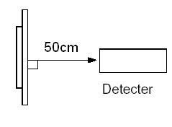
Note 2: The luminance uniformity is calculated by using following formula.
⊿Bp = Bp (Min.) / Bp (Max.)×100 (%)
Bp (Max.) = Maximum brightness in 9 measured spots
Bp (Min.) = Minimum brightness in 9 measured spots.
Active area

Note 3: The definition of viewing angle:
Refer to the graph below marked by θ and Ф

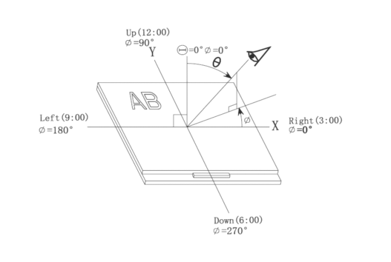
Note 4: Definition of contrast ratio.( Test LCD using DMS501)
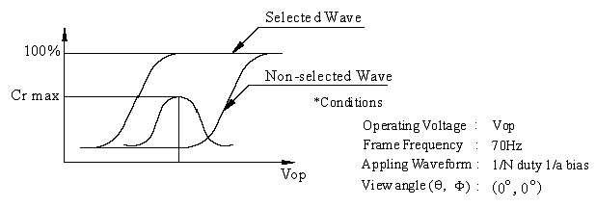
$$\text{Contrast}\text{ratio}\left(\text{Cr}\right)=\frac{\text{Brightness}\text{of}\text{selected}\text{dots}}{\text{Brightness}\text{of}\text{non}−\text{selected}\text{dots}}$$
Note 5: Definition of Response time. (Test LCD using DMS501):
The output signals of photo detector are measured when the input signals are changed from “black” to “white”(falling time) and from “white” to “black”(rising time), respectively. The response time is defined as the time interval between the 10% and 90% of amplitudes.Refer to figure as below.
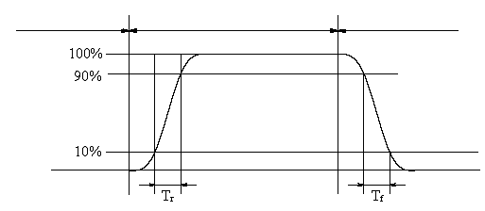
The definition of response time
Note 6: Definition of Color of CIE Coordinate and NTSC Ratio.
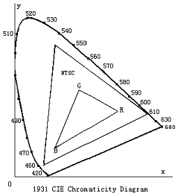
Color gamut:

$$S=\frac{\text{area}\text{of}\text{RGB}\text{triangle}}{\text{area}\text{of}\text{NTSC}\text{triangle}}×\text{100\%}$$

Note 7: Definition of cross talk.
Cross talk ratio(%)=|pattern A Brightness-pattern B Brightness|/pattern A Brightness*100
Pattern A
Pattern B
Measurement point(center)

Electric volume value=3F+/-3Hex

8. Reliability Test Items and Criteria
Test Item | Test condition | Remark
High Temperature Storage | Ta = 80℃ 96hrs | Note1,Note4
Low Temperature Storage | Ta = -30℃ 96hrs | Note1,Note4
High Temperature Operation | Ts = 70℃ 96hrs | Note2,Note4
Low Temperature Operation | Ta = -20℃ 96hrs | Note1,Note4
Operation at High Temperature/Humidity | +60℃, 90%RH 96hrs | Note4
Thermal Shock | -30℃/30 min ~ +80℃/30 min for a total 10 cycles, Start with cold temperature and end with high temperature. | Note4
Vibration Test | Frequency range:10~55Hz  Stroke:1.5mm  Sweep:10Hz~55Hz~10Hz  2 hours for each direction of X. Y. Z.  (6 hours for total)
Mechanical Shock | 100G 6ms,±X, ±Y, ±Z 3 times for each  direction
Package Vibration Test | Random Vibration :  0.015G*G/Hz from 5-200HZ, -6dB/Octave  from 200-500HZ  2 hours for each direction of X. Y. Z.  (6 hours for total)
Package Drop Test | Height:60cm 1 corner, 3 edges, 6 surfaces
Electro Static Discharge | ±2KV, Human Body Mode, 100pF/1500Ω

Note 1: Ta is the ambient temperature of samples.

Note 2: Ts is the temperature of panel’s surface.

Note 3: In the standard condition, there shall be no practical problem that may affect the
display function. After the reliability test, the product only guarantees operation,
but don’t guarantee all of the cosmetic specification.

Note 4: Before cosmetic and function test, the product must have enough recovery time,
at least 2 hours at room temperature

9. Precautions for Use of LCD Modules

9.1 Handling Precautions
9.1.1 The display panel is made of glass. Do not subject it to a mechanical shock by dropping it from a high place, etc.
9.1.2 If the display panel is damaged and the liquid crystal substance inside it leaks out, be sure not to get any in your mouth, if the substance comes into contact with your skin or clothes, promptly wash it off using soap and water.
9.1.3 Do not apply excessive force to the display surface or the adjoining areas since this may cause the color tone to vary.
9.1.4 The polarizer covering the display surface of the LCD module is soft and easily scratched. Handle this polarizer carefully.
9.1.5 If the display surface is contaminated, breathe on the surface and gently wipe it with a soft dry cloth. If still not completely clear, moisten cloth with one of the following solvents:
— Isopropyl alcohol — Ethyl alcohol
Solvents other than those mentioned above may damage the polarizer. Especially, do not use the following:
— Water — Ketone — Aromatic solvents
9.1.6 Do not attempt to disassemble the LCD Module.
9.1.7 If the logic circuit power is off, do not apply the input signals.
9.1.8 To prevent destruction of the elements by static electricity, be careful to maintain an optimum work environment.
a. Be sure to ground the body when handling the LCD Modules.
b. Tools required for assembly, such as soldering irons, must be properly ground.
c. To reduce the amount of static electricity generated, do not conduct assembly and other work under dry conditions.
d. The LCD Module is coated with a film to protect the display surface. Be care when peeling off this protective film since static electricity may be generated.

9.2 Storage precautions
9.2.1 When storing the LCD modules, avoid exposure to direct sunlight or to the light of fluorescent lamps.
9.2.2 The LCD modules should be stored under the storage temperature range. If the LCD modules will be stored for a long time, the recommend condition is:
Temperature : 0℃ ～ 40℃
Relatively humidity: ≤80%
9.2.3 The LCD modules should be stored in the room without acid, alkali and harmful gas.

9.3 The LCD modules should be no falling and violent shocking during transportation, and also should avoid excessive press, water, damp and sunshine.

“Disea Electronics Co., Ltd. reserves the right to change this specification.”

ADD: 5F,#3 Building, TianFuAn Industrial park,LeZhuJiao,ZhouShi Road,
XiXiang Town,BaoAn District, ShenZhen City,GuangDong Province , China
URL:http://www.diseaelec.com

- END

